**DAILY ONLINE ACTIVITIES SUMMARY**

|  |  |  |  |  |  |  |  |  |
| --- | --- | --- | --- | --- | --- | --- | --- | --- |
| **Date:** | **18-6-2020** | | | | | **Name:** | **Poojashree T** | |
| **Sem & Sec** | **8th sem B sec** | | | | | **USN:** | **4al16cs064** | |
| **Online Test Summary** | | | | | | | | |
| **Subject** | | **SMS** | | | | | | |
| **Max. Marks** | | **60** | | **Score** | | | **Not Received** | |
| **Certification Course Summary** | | | | | | | | |
| **Course** | **Introduction to R language tutorial** | | | | | | | |
| **Certificate Provider** | | | **Great learning academy** | | **Duration** | | | **3.0hr** |
| **Coding Challenges** | | | | | | | | |
| **Problem Statement:** **1**. **to read the number and compute the series.**  **2. to count the number in th series.**  **3. to check whether number is palindrome or not.**  **4. to find the number between 0 and 50 which are not divisible by 2 and 3.**  **5.micro and array update**  Top of Form | | | | | | | | |
| **Status:completed** | | | | | | | | |
| **Uploaded the report in Github** | | | | | **yes** | | | |
| **If yes Repository name** | | | | | **Poojatgowda** | | | |
| **Uploaded the report in slack** | | | | | **yes** | | | |

**Online test**

Not Received Mail

**Certification course**

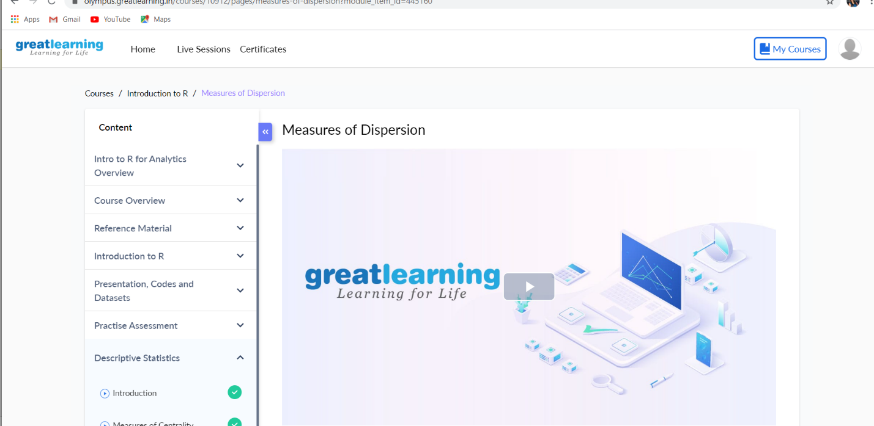

Coding

|  |  |
| --- | --- |
|  |  |

**3) Nesting of JSON objects:**

Another way of doing the same thing that we have done above.

var students = {

"steve" : {

"name" : "Steve",

"age" :  "29",

"gender" : "male"

},

"pete" : {

"name" : "Peter",

"age" : "32",

"gender" : "male"

},

"sop" : {

"name" : "Sophie",

"age" : "27",

"gender" : "female"

}

}